# CS 255 System Design Document – Mahdi Bigdely

## UML Diagrams

### UML Use Case Diagram

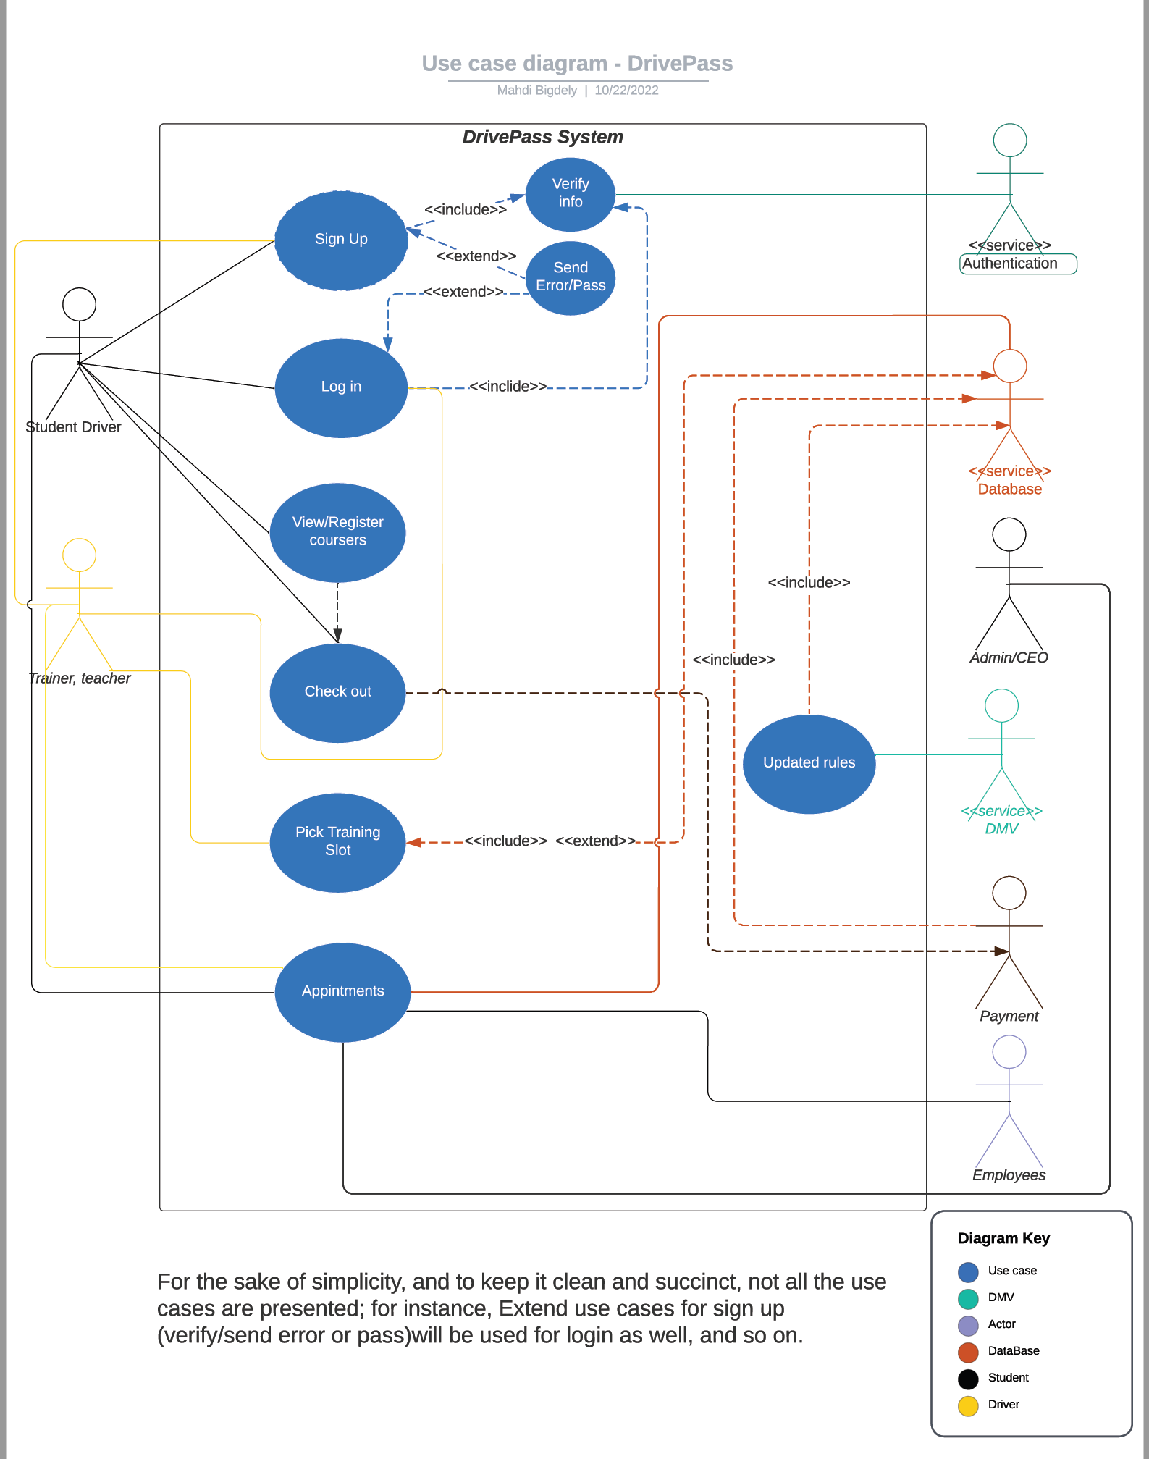

### UML Activity Diagrams

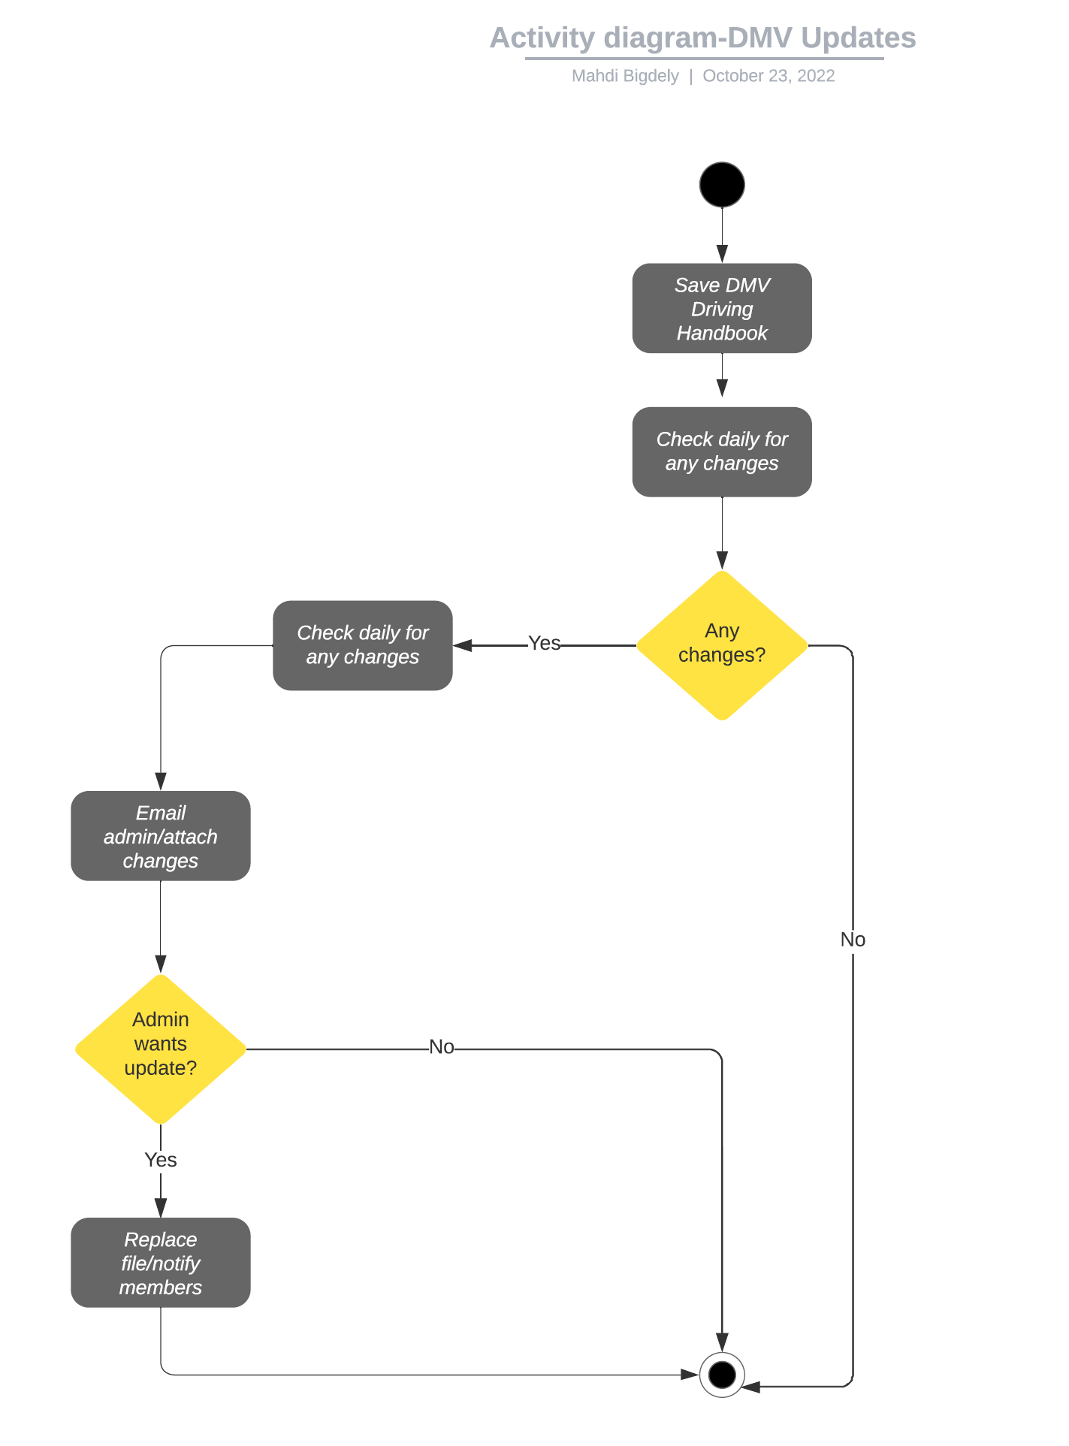

### UML Sequence Diagram

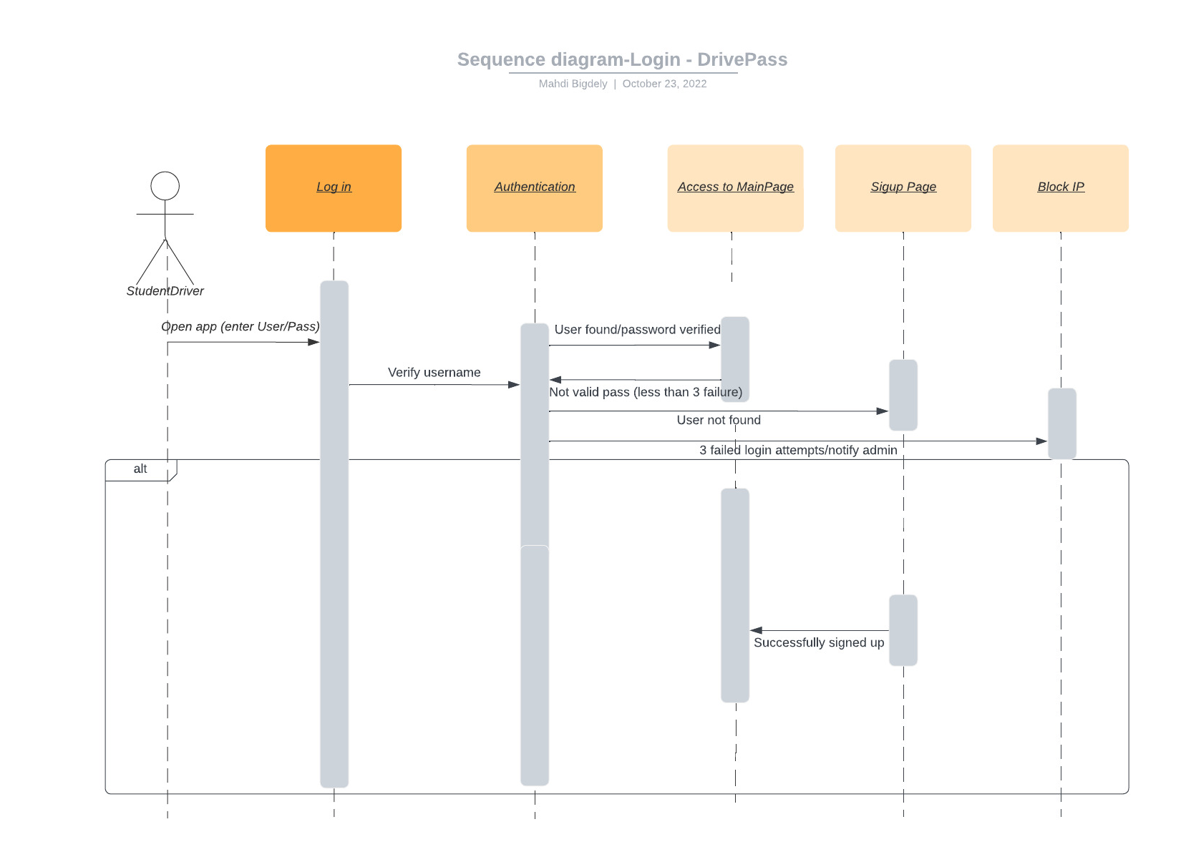

### UML Class Diagram

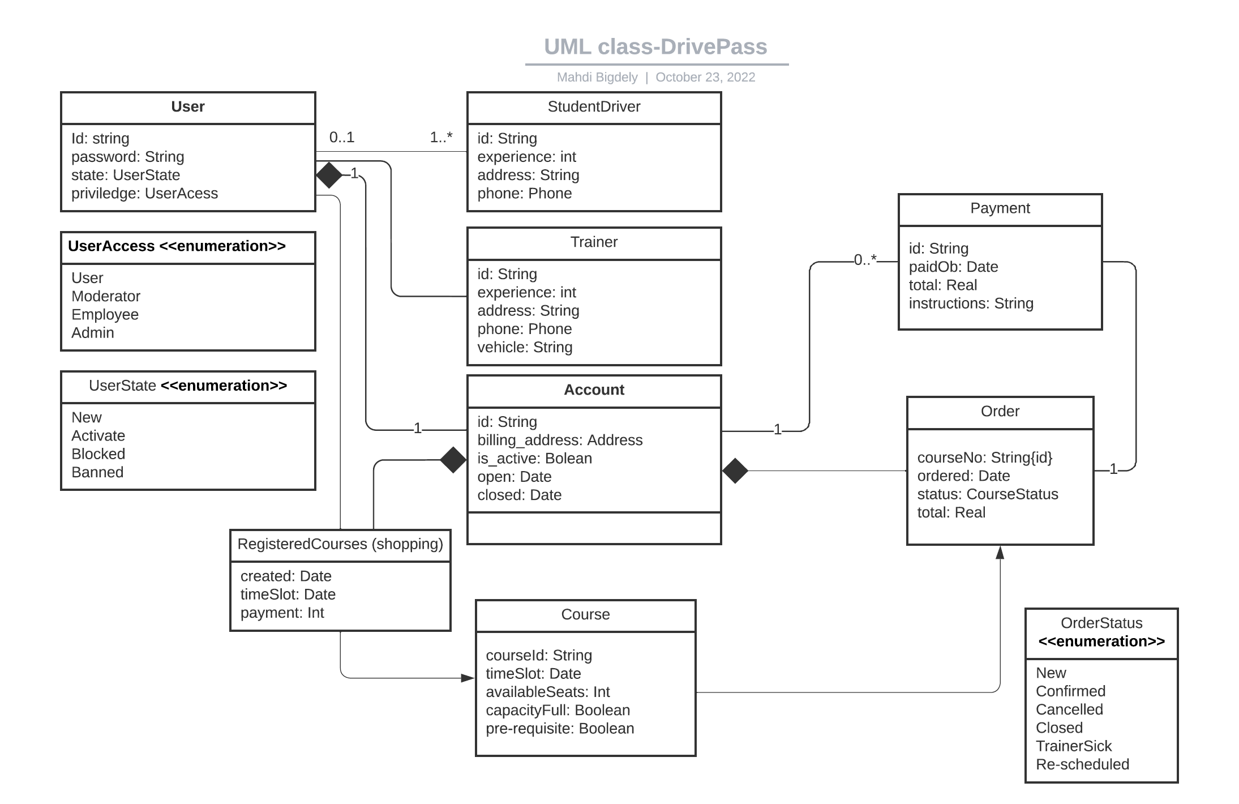

## Technical Requirements

The application should be equipped with strong cipher graph algorithm (a minimum of 128-bit AES encryption is required and 256-bit AES encryption is encouraged). To deliver fast and good quality content to customers regardless of their location, a cloud service needs to be used. To keep the communications safe and to prevent slow connection, it is recommended to encrypt the data that sensitive, such as user’s info, payments, login info, and similar information. A Unix based OS is recommended as the hosting application for DrivePass and Strapi (Node/JavaScript back-end CMS) is recommended to design back-end RESTful API. Strapi provide great support to deliver smooth, consistent and fast output on different devices such as phones, tablets, PCs, etc. To make sure that the front-end output correctly shows on various devices, Java is recommended as the from-end programming language, as it save a lot on resources, and we do not have to rewrite the code for each device/OS (we may need to some minor or even major changes in the code, depending on what we are planning to do).   
For smooth checkouts, the payments gateways for Visa, PayPal, Venmo, Amex, Discover, and Google Pay are suggested. The system needs to automatically backup and encrypt the server data at least once a day, and save them on a separate location for emergency situations. Special measures to block DoS, DDoS, and DNS amplification or similar attacks should be implemented, and expert opinion should be gathered to improve the application’s security.